CETYS University System


Institutional Academic Program Review Policy

February 2009

Institutional Academic Program Review Policy

Content.
 | Introduction | 3
1 | Duration of school periods and class sessions, in accordance with current official standards and norms. | 4
2 | Structure and magnitude of academic programs to attend and operate the Institutional Educational Model | 6
3 | Structure and magnitude of the Higher Education academic programs to respond to market needs and institutional strategy | 9
4 | Organization, program review process and participation of external experts. | 10
5 | Structure and content of the Self-study of each academic program and calendar for periodic academic program review. | 14
6 | Definition of the academic programs that will undergo review | 16
7 | Final comments | 18
8 | References | 19
9 | Appendix A: 279 Course format | 20
10 | Appendix B: New typology for the classification of Higher Education faculty for the CETYS University System | 23
11 | Appendix C: Format for the documentation of an undergraduate academic program. | 25
12 | Appendix D: Format for the documentation of an undergraduate academic program. | 29

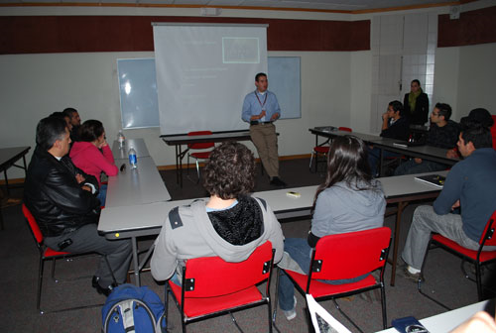

CETYS University System.
Vice-President of Academic Affairs.
Academic Program Review Policy
February 2009.

Introduction.
This academic program review policy of CETYS University has been approved by the President, the Vice-President of Academic Affairs and the College Directors. Work on this policy began in September 2008 and has been enriched by experiences from other higher education institutions from the United States, in which periodic and systematic program review is recognized as one of the better practices in higher education, to maintain updated and current academic programs. The policy is established as a basic reference that the academy of CETYS University may use for curricular review of the institution's higher education academic programs.

The periodic program review policy arises from recommendations made by the WASC Commission, and as a consequence from the accreditation process that must be followed with this regional accreditation agency in the United States. However, this activity is not a new one for the Academy of CETYS, because program review activities have been undertaken in CETYS under the denomination of Curricular Review or Curricular Redesign. These activities were executed in the past under guidelines established by the Educational Director or the Presidency [14, 15]. This was the mechanism through which the CETYS University System revitalized and updated its academic programs. The Academic Program Review Policy integrates many of these guidelines and experiences seeking to enrich learning and the experience of the student throughout his or her stay in the institution. In parallel, the Periodic Academic Review Policy seeks for the academic programs to be in the continuous improvement cycle. This is a systematic focus on quality improvement and competitiveness for the academic programs of CETYS.

The Periodic Academic Program Review Policy is based on the articles of the First and Second Sections of the current Institutional Statutes [2], as well as globalization and modernization aspects that the world demands on a higher education graduate. Also, the guidelines of the policy seek to establish a general, but standardized structure for the undergraduate and master's programs that is congruent with the requirements of the Higher Education authorities in México (Federal and State), the various educational governmental agencies (Federal and State), as well as national accreditation and certification agencies; but at the same time meeting the curricular needs and aspirations of the various colleges and schools that integrate the CETYS University System. In consequence, besides seeking the optimal operation of the Institutional Educational Model, also seeking that the curriculum be flexible, generating scale economies and the use of the installed capacity (facilities and faculty) and be oriented to educational effectiveness.

The Periodic Academic Program Review Policy establishes guidelines in the following aspects of the Higher Education curriculum:

- Duration of school periods and class sessions, in concordance with official standards and norms.
- Structure and magnitude of Higher Education academic programs to attend the philosophical and pedagogical principles as well as the various shades of the Institutional Educational Model.
- Structure and magnitude of the Higher Education academic programs to respond to market needs and scale economies in the use of installed capacity, as well as requirements established by the accrediting and certification agencies.
- Evaluation of the competitiveness of the Higher Education academic programs.
- Academic organization to execute the Periodic Academic Program Review process, as well as participation of External Experts in the review process that serve to enrich the quality of the academic programs with their feedback.
- Structure and content of the self-study of each academic program and calendar for the Periodic Academic Program Review process.
- Definition of the academic programs that will be subject to review.

The primary objective of the Periodic Academic Program Review is to provide the academy of the CETYS University System a mechanism that allows it to maintain all the academic programs in a continuous improvement process, which in turn allows for the identification and elimination of weaknesses in the programs and to extend or increment their strengths. The Periodic Academic Program Review Policy seeks that this process in order and effective, but also that the history of each academic program be documented to not redo the same mistakes and instead replicate the successes and academic best practices. To achieve the purpose of the Periodic Academic Program Review Policy, it must be itself reviewed when necessary. This being said, it follows to describe each of the elements of the Periodic Academic Program Review Policy.

1. Duration of school periods and class sessions in concordance with official standards and norms.
In the undergraduate level, and considering that the logistics and operation of the institution is by semester cycles, the semester will still be used as the measure of duration for an academic program at this level. However, because of the need to generate spaces during the summer, to evaluate, reflect and improve the academic planning and operation, it is necessary to reconsider the current duration and scheduling so as to generate these spaces. Alternatives are: (1) reduce the semesters from 16 weeks (80 work days) to 15 weeks (75 work days), therefore obtaining at least two weeks during the summer for the purposes mentioned before; or (2) continue with a 16 week semester, but with modifications to the current scheduling, beginning before in January and August. This second alternative must consider the response of the academic and administrative processes, as well as the real possibility of modifying them if necessary.

It is important to consider the possibility or even the need to match the scheduling of the graduate masters programs to that of the undergraduate programs. This to seek that some advanced graduate masters courses may be taken by undergraduate students when their academic programs have areas of concentration, emphasis or specialty. Currently, the graduate masters programs are operated in trimesters of 10 weeks, while the undergraduate programs operate by semesters. If both systems are to be matched, an evaluation of all implications must be made. This evaluation and the decisions emanated by it are a responsibility of the College Directors and the Vice-presidency of Academic Affairs.

Currently, all undergraduate programs have a duration of 8 semesters and the same amount of credits. The SEP 279 Agreement [3] establishes in Article 13, paragraph II, that the minimum number of credits for an undergraduate program must be 300. With regards to the number of classroom hours per week, the academy will evaluate the advantages of this number being 3 or 4, or a combination of both. The evaluation will be done under the perspective that the students achieve the learning outcomes, of the academic program as well as the institutional ones; as well as the perspective of the present capacity of the institution to manage and deliver the academic program under review. The focus is to do the best with the installed capacity and the current human resources. Thus, it is ratified that the number of total credits and duration must be the same for all undergraduate academic programs. The number of credits of the program is the basis used by the administration to define tuition; therefore it is important to have this under consideration so the resulting programs are not overcharged in credits, or with a dispersion in the total number of credits. The amount of credits per course will continue to be established based on Article 14 of the SEP 279 Agreement [3]. Which indicates that each effective hour of learning activity will have 0.0625 credits assigned. The effective hours of learning may be under the guidance of an academic (in person class hours for example) o as independent work that the student does. Article 15 states that the number of hours under guidance of an academic must be at least 2400 for undergraduate programs. However, since the CETYS University System has begun to utilize On-Line Education in some undergraduate courses, it is important to consider in the Academic Program Review Policy that the current academic programs may create new programs under this modality: mixed. In this case, it is important to pay special interest in the integration of the number of credits in the definition of in person hours, all this in concordance with the SEP 279 Agreement.

With regards to the weekly work load for an full time undergraduate student, if the expectation is still that the student do 4 hours of independent work per week for each course taken by semester, then we must be realistic with regards to the number of course that should be taken by semester and establish a structure of credits that is congruent with this standard. Also that faculty truly demands and verifies this level of independent work. The academic administrators must observe that faculty as well as students to their part. Special care must be given in the mixed modality, because in this case the dedication of the student is key to continuing and concluding in a successful manner the academic program. The Evaluation of the Academic Reform of 2004 [4] indicates that only in the engineering programs is this expectation of 4 hours of independent work achieved.

In conclusion: (1) all undergraduate academic programs are open to the traditional or mixed modality. (2) The duration of the traditional programs will be of 8 semesters and the same number of credits, being the minimum of 300 or 4800 hours of effective learning activity. In the case of the mixed modality it will be flexible according to the 279 Agreement. (3) The semesters will be of 15 or 16 weeks, whichever results in an optimal situation to generate a space of at least 2 weeks during summer. (4) For the traditional programs, the academy will define, after evaluating what is more adequate for the success of the students, the number of class hours per week, 3, 4 or a combination of both, for each course. In the case of the mixed modality the duration will be flexible according to the 279 Agreement. (5) The academy will define how many independent work hours per week must be done by the student to contribute to his or her success. (6) The SEP 279 Agreement is the basis to define the number of credits for academic programs and courses, for both undergraduate and graduate programs.

Table 1 reflects how the 2004, 2005 and 2006 undergraduate programs are integrated with regards to the number of courses and credits.

Table 1: Total credits and courses of current undergraduate academic plans.
College/Plan | Courses | Credits | Semester Tuition 2008 | $/course
ENG/2004 | 42 | 328 | $45,160 PESOS | $9,032 PESOS
ENG/2005 | 42 | 328 | $45,160 PESOS | $9,032 PESOS
ENG/2006 | 42 | 328 | $45,160 PESOS | $9,032 PESOS
BUS/2004 | 42 | 328 | $43,058 PESOS | $8,612 PESOS
PSYC/2006 | 42 | 328 | $43,058 PESOS | $8,612 PESOS

This table is the reference point for the design of the undergraduate programs and to evaluate the impact that may arise in current tuition by incrementing the number of credits or course for each program.

For the masters programs, the school periods are by trimesters (10 weeks). The engineering, law and business programs have 14 courses, while the education programs have 15 and the psychology and criminology have 16. Each course has 6 credits that imply 36 hours of in person class and 60 independent work hours. The satisfaction surveys that the Institution applies [5] show that the in person hours under guidance of a professor are insufficient. The duration of the course must be defined so students and professor have the necessary time for learning to occur. It is important to visualize the operation of the graduate programs, particularly with regards to faculty practice, that it is not an extension of undergraduate students, but seeks that graduate students participate in accordance to what studies of this level demand: more capacity for reading, more assertive participation and discussion in class activities, more professor independence and a better capacity for research in information sources. With regards to the number of courses and credits of a masters' program, the SEP 279 Agreement will be the basis for the definition of these quantities. In particular, for the number of credits in a masters' program, the 279 Agreement states in Article 13 Chapter III, that the number must be of at least 75 credits. In a same manner, Article 15 indicates that for the masters, the minimum number of hours under the guidance of an academic must be 300 hours in traditional modality, and that this number may be less if it is a mixed modality. Therefore, the selection of the modality is key to the curricular design of the programs.

In conclusion, with regards to the duration, number of courses and credits of the masters programs of the same nature (modality and orientation), these three parameters must be the same.

2. Structure and magnitude of academic programs to attend and operate in an optimal manner the Institutional Educational Model.

In accordance with the Institutional Educational Model and the integral education that the institution promotes, the undergraduate and graduate programs must incorporate in a pertinent and optimal manner the pedagogical principles and shades of the Institutional Educational Model. Figure 1, shows in a synthesized manner, for the case of undergraduate programs, the structure of these at this level. In reference to this figure, all undergraduate academic programs must develop in students abilities in thes three areas:
❶ Abilities that prepare the student for the workforce and graduate studies. Included here are elements of integral education such as: verbal reasoning, quantitative reasoning, critical thinking and problem solving, as well as those derived from the institutional learning outcome for Continuous Learning (access and use of information). The development of these abilities must be in the first two years of undergraduate studies. This learning make operational the learning to learn facet of the Institutional Educational Model.
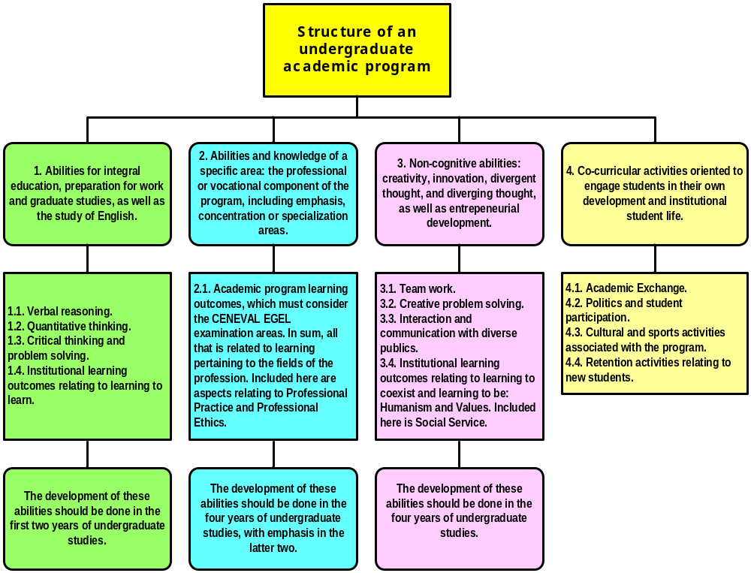
Fig. #1(a). Structure of an undergraduate academic program.
❷ Abilities that prepare the student for the exercise of the profession/vocation. Included here are all the learning outcomes that define the professional exit profile for the student. These include essential knowledge of the profession and the specialization/concentration areas, their understanding and application. This learning must be aligned with the cognitive areas of the EGEL CENEVAL examination, but without losing focus on the institutional perspective. The exercise of Professional Practice must be included in the curriculum and be strongly associated to reinforce the essential learning of the profession and not as a mere requisite of the academic program. For these purposes, two courses denominated "Professional Practice I and II", which will be in the last year of the program. In these group of abilities the learning to do and be in the professional ambit will be emphasized. This learning must be programmed, preferably since the beginning of the program and be present throughout the academic program, intensifying in the last two years of the program. The idea is that the student reinforce the vocation or decide in time if he or she should change academic programs.

❸ Non-cognitive abilities that prepare the student for the aspects of innovation, creativity, entrepreneurism as well as cultural and professional diversity. Included here are the learning outcomes associated with diverging thought, tolerance and diversity (ideas, cultural, professional and disciplines) and global understanding. The emphasis is in learning to co-exist and achieve that the students develop aperture to diversity, as well as a social conscience, that helps them confront the challenges of their professional and social lives. These includes the exercise of Social Service, as part of the curriculum and strongly aligned with institutional strategies of linkage with the community. For this purpose, two courses are integrated beginning in the second year, "Social Service I and II".

The abilities in this area must be develop during the 4 years of undergraduate studies with a tendency to concentrate on the last three years of the academic program. Also, emphasis in class room groups integrate by students of diverse academic programs is suggested, so they experience a multidisciplinary environment, similar to what will occur in their professional life.

❹ Co-curricular activities of the academic program. By design, but seeking scale economies, all academic programs must contribute, via a series of events and co-curricular activities, to create an environment in which students of each academic program develop their full potential. These events seek the organized involvement of students with the support of the Student Affairs Department, School Directors and Academic Program Coordinators, International Programs Department, and Centers for Student development (CEDEs). The nature of the events may be cultural, sporting, professional, or social. These events and activities must contribute in the development of a culture of identity with the academic program and strengthen the differentiation aspects of the program. Figure 1(b) indicates that the undergraduate curricular project, without leaving behind the graduate model, involves and requires that the various support areas for the academy: Library, Information Resources, Values and Humanism Center, as well as the –Centers- that promote the shades of the Institutional Educational Model; contribute to create an environment of learning for students and reflect their services from a perspective of learning outcomes. These areas must ask: ¿What must a student learn about my services and how may I contribute to student success?
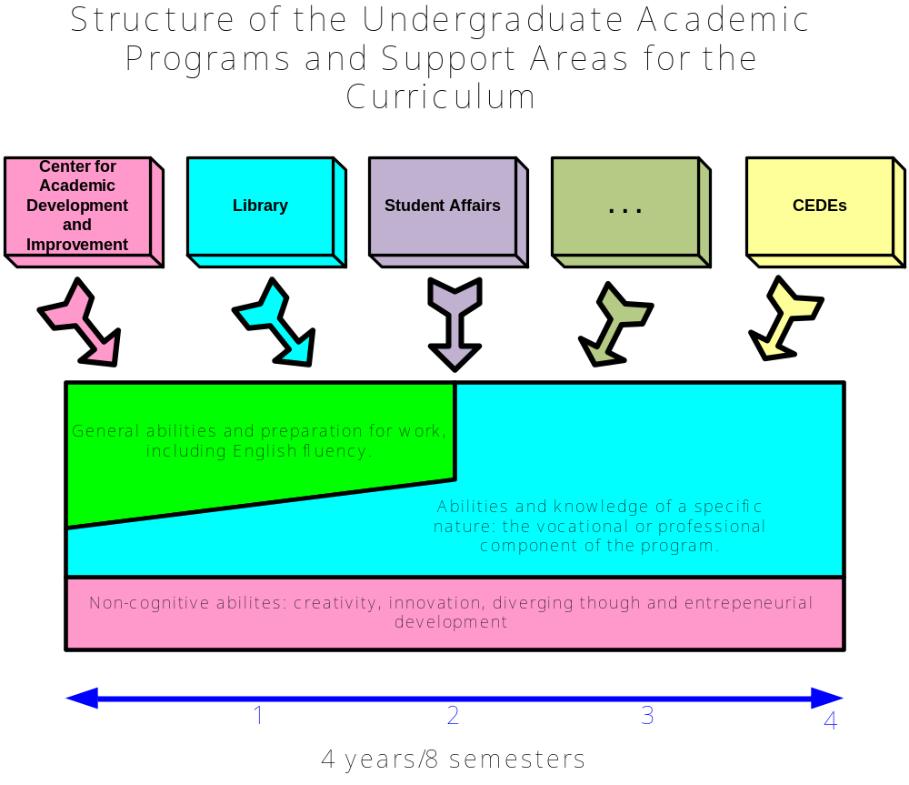
Fig. #1(b). Structure of Undergraduate Academic Programs and Support Areas for the Curriculum.

With regards to the masters programs, we look to the SEP 279 Agreement to identify the orientation of the masters programs: professional exercise/practice or research. There are significant differences between each orientations with regards to full time faculty participation as well as program structure and content.

Appendix D includes three generic curriculum tables for Engineering, Business and Social Sciences/Humanities. These are not definitive, but integrate a set of courses that the Vice-Presidency of Academic Affairs and the College Directors have defined for the first three areas of figure 1(a9. The names of these courses, their credits, sequence and codes are not definitive, and will be defined, seeking scale economies and congruency between programs.

3. Structure and magnitude of the Higher Education programs to respond to market needs and institutional strategy.
All undergraduate and graduate masters academic programs, as part of their review process must be subject to a –Benchmarking- analysis, comparing them to the best programs of the same type in the United States and México. For this effect a limited number of academic indicators of admission, capacity and educational effectiveness will be used. Table 2 establishes the indicators for comparison.

Table 2: Academic Indicators for Benchmarking with other similar programs.
Type of indicator | Description | Comments
Admission. These indicators give an idea of the quality of the students that enroll in the academic program as well as the demand of the academic program. | A1. Average Score obtained from the admission examination for undergraduate and graduate as well as the standard deviation. | Analysis of 2004-2008 period from August 2004. Identify tendencies.
 | A2. New student enrollment, and total re-enrollment. | Analysis of 2004-2008 period from August 2004. Identify tendencies.
 | A3. Ratio between admission requests and accepted students. | Analysis of 2004-2008 period from August 2004. Identify tendencies.
Capacity. These indicators make reference to the amount of critical resources that guarantee student success. | C1. Ratio between the number of equivalent full time students (EFTS) and the number of equivalent full time faculty (EFTF). | Analysis of 2004-2008 period from August 2004. Identify tendencies.
 | C2. Curricular coverage: % of hours of the total program covered by a EFTF. | Analysis of 2004-2008 period from August 2004. Identify tendencies.
 | C3. Average size of class groups. | Analysis of 2004-2008 period from August 2004. Identify tendencies.
 | C4. Square meters of exclusive construction for the academic program per student. | Analysis of 2004-2008 period from August 2004. Identify tendencies.
 | C5. Program accreditations. | Is the program accredited? If so, since when?
 | C6. Available information resources for the students of the program. | Actual number of available information resources for students of the program.
 | C7: Faculty prestige. | Actual number of full time faculty with national and international recognition.
 | C8. Faculty assigned to the program: type, rank, time in institution, age. | Besides the number of faculty, include each of the indicated characteristics.
Educational Effectiveness. These indicators allow for the evaluation of the measure in which learning occurs and how the institution responds to the needs of the students and the community. | E1. Terminal efficiency. | Analysis of 2004-2008 period from August 2004. Identify tendencies.
 | E2. Number of graduates per period. | Analysis of 2004-2008 period from August 2004. Identify tendencies.
 | E3. Success of the program alumni. | Measured in relation to the achievement of the educational objectives of the program and the perception of its professional success.
 | E4. Faculty productivity. | Perception of the prestige of the faculty or any other measure like the number of publications per period.
 | E5. Program learning outcomes. | Analysis of 2004-2008 period from August 2004. Identify tendencies.
 | E6. Institutional learning outcomes. | Analysis of 2004-2008 period from August 2004. Identify tendencies.
 | E7. Student satisfaction with the received education. | Analysis of 2004-2008 period from August 2004. Identify tendencies.
 | E8. Performance in national standardized tests. | Analysis of 2004-2008 period from August 2004. Identify tendencies.

The reasons behind this comparison is to identify ways to increase the competitiveness of the academic program under review and look for the possibility of incorporating best operational practices and performance metrics that contribute to strengthen the competitiveness of the program under analysis.

4. Organization, program review process and external expert participation.
The review of academic programs is a task and responsibility of the faculty. It corresponds to the faculty to organize itself in the best manner possible, so the review results in an optimal manner, in the use of resources, as well as time and forms of the results. The college directors and Vice-Presidency of Academic Affairs has opted for an organizational scheme based on Academies for this task. The following policies must be observed for the integration and operation of the Academies:

PO01: The academies are academic bodies integrated by faculty, with two specific tasks: (1) program review of the undergraduate and masters' programs, and (2) assessment activities associated with the academic programs of the CETYS University System. The academies are the means to guarantee that the curriculum of higher education has a mechanism or system for continuous improvement.

PO02: The academies must be integrated seeking gender diversity, representation of various types of faculty that participate in CETYS University, its schools and when pertinent, the representation of the colleges of the CETYS University System.

PO03: The integration of the academies is the responsibility of the College Directors. The conformation of an academy will be registered in a document that indicates its members, the period of duration of each in the academy, and the reason or primary objective of the academy. This document must be communicated to the Vice-presidency of Academic Affairs for approval and for follow-up of the Academic Program and Assessment.

PO04: The period of duration of a member in an academy will be a minimum of 2 years. After this period, the faculty member may abandon the academy or continue for another 2 years. The College Directors are responsible for approving extensions or terminations of membership in the academy.

PO05: Academies may be integrated for academic programs, areas that integrate various disciplines or a discipline in particular. It is responsibility of the College Directors to define the type of academies that are required so their academic programs are reviewed and assessment may be done in a systematic manner for the learning outcomes of the academic programs.

PO06: Each academy will have a speaker (with substitute) to represent the members of the academies to other academies, or other internal or external collegiate bodies. In the document of the academy the speaker must be registered as well as the substitute. The internal organization of the academy is the responsibility of its members and college directors. However, it is required as a minimum, that this organization include a coordinator of meetings, and a secretary. The Coordinator of the academy requires a protocol or rulebook to allow the coordination and participation of members (participation rounds, agreements, etc.).

PO07: In the case of ordinary full time and half time faculty, part time and full time research, associates and visitors; the work done in the academies will be linked to the activities of integration, application and discovery of knowledge; so this must not be seen as something separate from academic work or as an additional task or extra element. However, in the case of ordinary per assignment faculty or adjuncts, their participation in academies will be subject to the conditions and specifications of their work contract. It is responsibility of the school and/or college directors that the work load of the faculty reflects the goals and objectives of their schools/colleges and the institution. The work of the academies is an activity that must be incorporated in the work load of the faculty and school/college directors.

PO08: The academies may coordinate activities relating to the formulation of academic program learning outcomes and for the areas and disciplines that are assigned to them; as well as instruments for assessment associated with said learning outcomes. In both cases, it is desirable that the generated products be formulated in a collaborative and collective manner accepted by the faculty involved. This requires that the academies elaborate, under the directions of the colleges, a protocol and policies for the realization of their meetings. It is suggested that this protocol and policies be the same for all academies and that it evolves as the academies evolve. This so as not to halt the Periodic Academic Program Review. If faculty does not give proposals, then the academies may make proposals and make operative the learning outcomes and the corresponding metrics, with the approval of the Colleges and the Vice-presidency of Academic Affairs.

PO09: With regards to learning outcomes and assessment, the academies may make suggestions and recommendations with regards to the modification of learning outcomes, their metrics or instruments of measurement, the pedagogical training/updating of faculty, and the creation of an environment that is apt for the students to achieve the desired learning outcomes and be successful at the end of their academic programs. These recommendations must be indicated to the college directors.

PO10: The academies may do periodic academic program review, under the guidelines established by the Vice-presidency of Academic Affairs and the college directors. The reference must be the Academic Program Review Policy and the generic program review process recommended by the Vice-presidency of Academic Affairs. This process is illustrated in figures 2, 3 and 4.

PO11: Within the Academic Program Review Policy, the academies are responsible for elaborating a self study, according to guidelines, procedures and times established by the Vice-presidency of Academic Affairs. For this effect, the School/College Directors must provide the necessary conditions and resources to achieve the expected results.

PO12: It is a responsibility of the academies to divulge the results of the periodic program review and assessment via the Academic Information Portal and the Institutional Electronic Portfolio, so that the results may be available to the academic community of the institution. For this purpose they will work in a coordinated manner with the Information Resources Department of each Campus, the School/College directors serving to facilitate this coordination.

PO13: For the academies to do these tasks in an efficient and effective manner, they must formulate an annual work plan that defines the actions and projects to do, as well as the meetings calendar for the year. An operations log will be integrated with the agendas, minutes, projects and annual work plan. These pieces of information are useful elements for accreditation processes, and it is recommended that an electronic format be available via the Academic Information Portal.

PO14: It corresponds to each academy to establish the guidelines to declare official the work sessions and decision making regarding proposals and agreements. These guidelines must be congruent with the current Statute and Policies and must be available in the Academic Information Portal so that all faculty may have access to them. As indicated in PO08 and with the purpose of maintaining congruency and uniformity in the operation of the academies, these should function with the same protocol and policies. It corresponds to the college directors to guarantee that this occurs.

PO15: Any situation that is not contemplated in these policies relative to the operation of the academies will be analyzed and resolved by the council of the Vice-presidency of Academic Affairs.

PO16: So the purpose of the Academic Program Review Policy and its academies maintain themselves in the continuous improvement cycle, the college directors will do a semester evaluation of performance of the academies of their corresponding colleges. They will define the necessary actions to improve their operation and results.
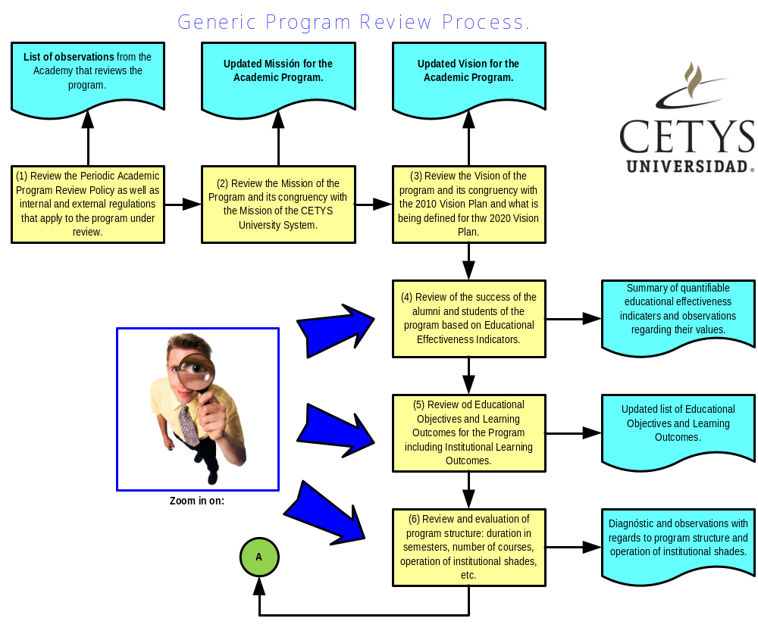
Fig. #2. Generic Periodic Academic Program Review Process.

These policies are not final. Their use and application will improve them, and this is why their periodic review is recommended to precise their content and application based upon the performance, effectiveness and efficiency of the academies.
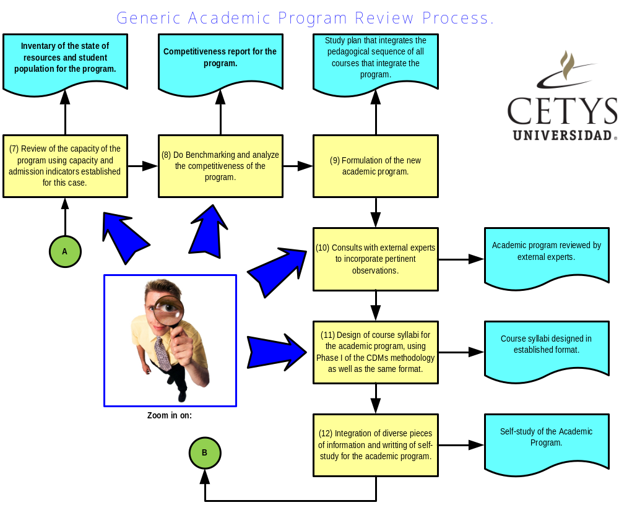
Fig. #3. Generic Periodic Academic Program Review Process.

With regards on how to conduct the Academic Program Review Policy, a basic process has been generated, illustrated in figures 2, 3 and 4. This process may be expanded and adjusted to the needs of each academy, however the generated products that are expected to be integrated into the –Self-study- are mandatory. The Generic Process for the Periodic Academic Program Review is integrated by a set of sub-processes, whose execution in sequence or in parallel, seeks to generate a set of products that are inputs for the –Self-study-. This study is a report that makes evident that an academic program has been reviewed and that a set of recommendations exists, including execution guides for the improvement of the program. With regards to figures 2 and 3, there are sub-processes/activities in which more analysis by the academies is required, as well as more details to consider that depend on the nature and resources of the program.

With regards to figure 3, step 10 is critical for the Academic Program Review process, because it is via this sub-process that we guarantee that the program is aligned to the needs of the community and receives a valuable feedback from external experts, that allow the academy to fine tune aspects that are relevant to the structure of the program under review. Each academy will define how to do this process, however it is recommended that the external committee review that reviews the academic program be integrated by at least two experts from institutions similar to CETYS in orientation, vocation and size. Figure 4 integrates the last three steps in the generic process for periodic academic program review. The cycle should be completed in the course of a school year.
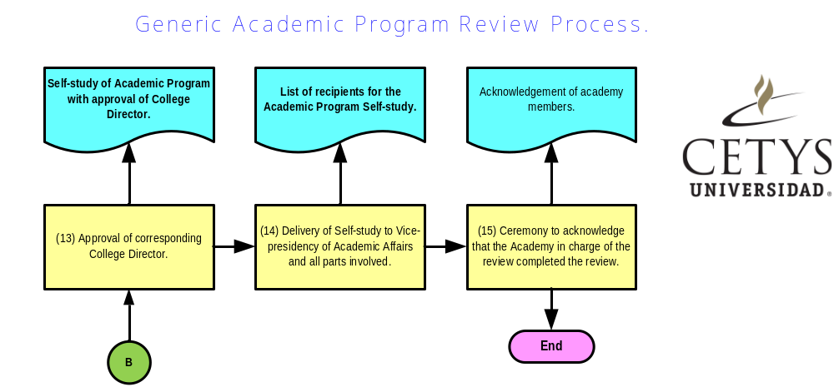
Fig. #4. Generic Periodic Academic Program Review Process.

5. Structure and content of the Self-study for each academic program and calendar for the periodic academic program review.
The –Self-study- that each academy must elaborate will have the following structure and content:

- Introduction. Must contain information regarding the identification of the program under review, as well as the team that participated in the review process including external experts.
- Analysis of the Mission of the academic program. Must explain how the program relates to the CETYS Mission. This section must include the educational objectives of the program, the Exit profile in terms of program and institutional learning outcomes, the Admission profile and the Graduation requirements.
- Analysis of the Vision of the academic program. Including the objectives and goals for the program in the next 5 years.
- Analysis of Direct Costs associated with the program.
- Analysis of new admissions, retention, terminal efficiency and graduation rates.
- Analysis of faculty and its quality.
- Analysis of resources (library, labs, special classrooms, etc.) that support the program.
- Learning outcomes and assessment. Must include assessment of program and institutional learning outcomes.
- Analysis of student and alumni satisfaction.
- Benchmarking with similar programs.
- Academic program with its pedagogical sequence and academic parameters. This part of the –Self-study- integrates all the relative information of the courses for the program (class hours per week credits, code), definition of elective courses, as well as Social Service and Professional Practice courses.
- Report of review by external experts.
- Academy recommendations for the improvement of the program.

Some of the elements indicated above must be presented in specific formats that are indicated as appendices to this document. The use of the formats requires uniformity and structure for the –Self-studies- and facilitates its integration to other institutional documents and for official registration.

Table 3 shows a suggested calendar to complete the Academic Program Review cycle, assuming the process initiates in a time of the signing of a Mutual Agreement Memorandum between the Vice-presidency of Academic Affairs and the college directors. From this moment on, the duration, measured in weeks, is defined for each of the activities detailed in the academic program review cycle.

Table 3: suggested calendar for the execution of the Academic Program Review.
# | Activity | Execution Period | Accumulated Time | Product
1 | Review of the Periodic Academic Program Review Policy by the academies. | Two weeks from the signing of the mutual agreement memorandum. | 2 | Meetings protocol, questions regarding how to conduct cycle.
2 | Analysis of the Mission of the program. | 1 week | 3 | Revised mission and communication strategy
3 | Analysis of the Vision of the program | 1 week | 4 | Revised vision including goals and objectives.
4 | Review of program effectiveness. | 2 weeks | 6 | Evaluation of alumni achievements and student success.
5 | Review of program educational objectives and learning outcomes. | 2 weeks | 8 | Educational objectives, learning outcomes and new or revised assessment tools.
6 | Review and evaluation of academic program structure. | 2 weeks | 10 | Re-structured program with course listing.
7 | Review of the capacity of the program. | 2 weeks | 12 | Capacity report of the program indicating improvement areas.
8 | Benchmarking and competitiveness of the program. | 2 weeks | 14 | Benchmarking for the program and competitiveness areas of improvement.
9 | Revised academic program. | 2 weeks | 16 | New proposal for the academic program with all its elements.
10 | External experts consult | 3 weeks | 19 | Recommendations by external experts.
11 | Course syllabi formulation | 5 weeks | 24 | Course programs.
12 | Integration of –Self-study- | 4 weeks | 28 | Self-study.
13 | Review by college director | 4 weeks | 32 | Approval of self-study by college director.
14 | Delivery of -Self-study- to the Vice-presidency of Academic Affairs for approval | 4 weeks | 36 | Finished -Self-study- for distribution
15 | Acknowledgement of the work of the academies by the college directors. | 4 weeks | 40 | Acknowledgements to academies.
The times are based on other institutions in the United States and represent only an approximation. Each academy must do the required adjustments to finish the program review during the year.

6. Definition of the set of academic programs that will be subject to review.
Table 4 indicates the academic programs that will be subject to review by the academy and external experts. The college and school directors are responsible for coordinating this review and ratifying the list indicated in the table. The review will begin once the mutual agreement memorandum between the college directors and Vice-presidency of Academic Affairs is signed. This document basically indicates the conditions under which the review will be done and the products that must be delivered.

Table 4: List of academic programs under review.
College | # | Name of program | Observations
ENGINEERING | 1 | Industrial engineering
ENGINEERING | 2 | Computer Science engineering
ENGINEERING | 3 | Electronic Cybernetics engineering
ENGINEERING | 4 | Mechanical engineering
ENGINEERING | 5 | Software engineering
ENGINEERING | 7 | Mechatronics engineering
ENGINEERING | 8 | Digital Graphic Design engineering
ENGINEERING | 9 | Masters of Science in Engineering | In coordination with the Graduate College and those responsible for this program.
BUSINESS | 1 | International Public Accounting
BUSINESS | 2 | Business Management
BUSINESS | 3 | International Business
BUSINESS | 4 | Marketing Management
BUSINESS | 5 | Graphic Design
BUSINESS | 6 | Law
BUSINESS | 7 | Service Management
BUSINESS | 8 | Masters in Business Administration | In coordination with the Graduate College and those responsible for this program.
SOCIAL SCIENCES / HUMANITIES | 1 | Psychology (Clinical, Educational, Child, and Organizational)
SOCIAL SCIENCES / HUMANITIES | 2 | Education Sciences
SOCIAL SCIENCES / HUMANITIES | 3 | Masters in Psychology | In coordination with the Graduate College and those responsible for this program.
SOCIAL SCIENCES / HUMANITIES | 4 | Masters in Education
SOCIAL SCIENCES / HUMANITIES | 5 | Masters in Criminology

Table 5 synthesizes the calendar for the academic program review process. The table indicates the year in which the academy must to the periodic review of a particular academic program. This table is fundamental in establishing priorities in which the academy should focus on the next 3 years and how this should be reflected in their work loads. The WASC 2009-2011 planning considers a budget to do this review task assuming a reference cost of $12,400 dollars per program. In 2013 the review cycle begins anew with the review of the programs that were analyzed in 2009.

Table 5: Programming for the Academic Program Periodic Review.
College | # | Name of the program | Observations | Review in:
ENGINEERING | 1 | Industrial engineering | The program is accredited by CACEI in MXL and TIJ campuses. In ENS, the program is in the CACEI self-study stage. | 2009
ENGINEERING | 2 | Computer Science engineering | The program is accredited by CACEI in MXL and the TIJ campus is awaiting response from the accrediting agency. | 2009
ENGINEERING | 3 | Electronic Cybernetics engineering | The program is accredited in MXL by CACEI. | 2009
ENGINEERING | 4 | Mechanical engineering | The program is accredited in MXL by CACEI. | 2010
ENGINEERING | 5 | Mechatronics engineering | Not yet eligible for accreditation | 2010
ENGINEERING | 6 | Digital Graphic Design engineering | Not yet eligible for accreditation | 2010
ENGINEERING | 7 | Software engineering | Not yet eligible for accreditation | 2011
ENGINEERING | 8 | Masters of Science in Engineering | In coordination with the Graduate College and those responsible for this program. | 2012
BUSINESS | 9 | International Public Accounting | Not accredited in MXL and it will be sent to 2009-1. The CACECA accreditation costs $80,000 pesos. + tax and includes the first accreditation visit and two review visits. Each additional review visit costs $25,000 pesos. | 2009
BUSINESS | 10 | Business Managements | The program is accredited since 2004 and there have been two reviews (2006, 2008). A third review is expected in 2009. | 2009
BUSINESS | 11 | International Business | Accredited in 2008-2 in MXL and TIJ. | 2009
BUSINESS | 12 | Marketing Management | Accredited in 2008-2 in MXL and TIJ. | 2010
BUSINESS | 13 | Graphic Design | Not yet accredited. | 2010
BUSINESS | 14 | Law | Will be presented for accreditation in 2009-1 | 2010
BUSINESS | 15 | Service Management | Not yet eligible for accreditation. | 2012
BUSINESS | 16 | Masters in Business Administration | In coordination with the Graduate College and those responsible for this program. | 2009
BUSINESS | 17 | Masters of Corporate and International Law | In coordination with the Graduate College and those responsible for this program. | 2011
SOCIAL SCIENCES / HUMANITIES | 18 | Psychology (Clinical, Educational, Child and Organizational) | Even though it is registered as 5 programs in SEBS, it will be reviewed as one program with concentration or emphasis areas. | 2012
SOCIAL SCIENCES / HUMANITIES | 19 | Education Sciences | Not yet eligible for accreditation. | 2012
SOCIAL SCIENCES / HUMANITIES | 20 | Masters in Education | In coordination with the Graduate College and those responsible for this program. | 2009
SOCIAL SCIENCES / HUMANITIES | 21 | Masters in Psychology | In coordination with the Graduate College and those responsible for this program. | 2010
SOCIAL SCIENCES / HUMANITIES | 22 | Masters in Criminology | In coordination with the Graduate College and those responsible for this program. | 2011

7. Final comments.
① Even though this is an a layout for doing periodic academic program review at CETYS, there are 2 processes that have been traditionally linked to Curricular Design. We are referring to the Official Registration of programs in SEBS and the Educational Marketing process. The –Self-study- generated by the review process is an input to produce the registration documents. Delivery dates for these registration documents must be established and we must follow what is established in Article 25 of the SEP 279 Agreement. This because the review process may generate updates of the current programs, which already have a registration. However, the Educational Marketing process must use the previous documentation and contemplate that in December 2009 new information may be available. It is important to note that changes in SEBS documentation may need additional resources to be generated.

② An old adage says that there is no free food. Applying this to the review process means that spending must be considered (travel, document integration for internal use and for registration, external experts, etc.), for these circumstances, the Vice-presidency of Academic Affairs must assign part of the budget and an account number where the amounts will be charged. The WASC 2009-2011, contemplates a budget for the 2009-2011 period. Said budget may suffer changes due to product and enrollment variations, and also because of fluctuations in the value of the peso.

③ The college and school directors must do follow-up to the execution of the review process. This to provide the necessary conditions to meet the deadlines for the deliverable products and expected results. Curricular Design in CETYS usually takes more time than what is planned when the academy does not find ways to achieve agreements. This is why the participation of the college directors is key so that things may run smoothly.

④ The Planning and Effectiveness Office, as well as personnel assigned to the Center for Academic Development and Improvement (CDMA) are available to provide orientation to the directors and the academies in the execution of the program review. But also, in collaboration with the College Directors, will provide monthly follow-up to the programmed work sessions.

⑤ Moving CETYS University towards the concept of a "Learning Organization", is a task that is not limited to the academic environment, it also requires the active participation of all support areas, who must include in their operation -learning outcomes- that are the basis so their -clients-, primarily students, understand how they are contributing to their development, and identify systematic mechanisms that give orientation in the improvement of their performance. The school directors must assure that the service of these support areas is provided to the academy, as indicated in figure 1(b), but also that it generates value and contributes to create an environment that provides for students to achieve the established learning outcomes.
 References.
1. Iowa State University. (2002). Academic Program Review: Policies and Procedures.
2. CETYS University System. (2004). Statute approved by the IENAC Council.
3. SEP Agreement 279. July 10, 2000.
4. Evaluation of the 2004v Academic Reform. Mexicali, B.C., México: CETYS University, 2008.
5. Satisfaction Study 2008-1. Mexicali, B.C., México: CETYS Universidad, 2008.
6. Mexicali Campus Focus Group; Mexicali, B.C., México: CETYS Universidad, 2005.
7. Dwayer, Carol a., Millett, Catherine M., Payne, David G. (2006). A culture of evidence: Postsecondary assessment and learning outcomes. Princeton, N. J., United States: ETS, 2006.
8. California State University. (2003). Academic Program Review.
9. University of Wisconsin System. (2006). Guidelines for academic program review & Regent Policy ACIS 1.0.
10. Ministry of Science, Technology and Innovation. (2005). A framework for qualifications of the European higher education area.
11. Oregon University. (2008). Program Review: Instructions for Self-Study Report.
12. University of New Hampshire. (2001). Undergraduate academic program review at the University of New Hampshire.
13. University of Nebraska. (2008). University Curriculum Committee: Committee Handbook.
14. Curricular evaluation guide for CETYS, 1985.
15. Curricular evaluation guide for CETYS, 1990.
16. San Francisco State University. (2001). Academic Program Review Sixth Cycle Handbook.

Notes: This information is available in the Office of the Director of Academic Planning and Effectiveness.
Appendix A:
279 Course Format.

This is the format to document all courses for the each academic program for the SEBS registration..



General course information
Course code and name |  |  | Write course code and name based upon the academic program study plan
Academic period: |  |  |  |  |  | Write academic period in which course will be offered
Cours description. Write the description of the course, which should inform the student and professor the following:
- What the course is about and it's duration in hours
- Relevance of course in study plan
- Semester in which the course is placed in the academic program study plan
- Nature of the course (theory, practice)
- Relationship with other courses in the academic program study plan
- Abilities that the student will develop
- Level of demands that the course will upon the student with regards to projects, research, presentations, lab work, etc.
Exit profile for the course:
Unit |  |  |  |  | Application level learning outcome
Write the name of Unit I |  |  |  |  | Write the learning outcomes for Unit I
Write the name of Unit II |  |  |  |  | Write the learning outcomes for Unit II
Write the name of Unit III |  |  |  |  | Write the learning outcomes for Unit III
Write the name of Unit IV |  |  |  |  | Write the learning outcomes for Unit IIV
Write the name of Unit V |  |  |  |  | Write the learning outcomes for Unit V
Entry profile for the course
The student must know: |  |  |  | The student must comprehend: |  |  |  | The student must know how to do:
Texts and references for the course
Authorized texts |  | Authorized references |  |  |  |  | Other assigned resourrces
Title  Author  Editors  Edition, year, ISBN |  | Title  Author  Editors  Edition, year, ISBN
Content:
# | Unit title |  |  |  |  |  |  |  | Assigned hours
1 | Write the name of Unit I
1 | Write the topics of Unit I
2 | Write the name of Unit II
2 | Write the topics of Unit II
3 | Write the name of Unit III
3 | Write the topics of Unit III
4 | Write the name of Unit IIV
4 | Write the topics of Unit IV
5 | Write the name of Unit V
5 | Write the topics of Unit V
Total de hours

Primary learning activities:
The learning experiences for this course will be of an individual and group nature. Activities done inside the classroom will be guided by a professor and the independent activities will be done by students outside the classroom. The generic learning activities that students will do are:
❶ Collaborative work in the classroom to analyze and debate topics under the guidance of the professor.
❷ Case studies to apply and evaluate course content.
❸ Cooperative work outside the classroom for case analysis and problem solving.
❹ Learning based upon structured and non-structured problems so students learn to formulate problems and apply the course content to generate solutions, from individual efforts as well as team work.
❺ Presentation of content by the professor.
❻ Learning based on application and/or research projects so students apply their knowledge of projects of their own interest.
❻ Visits to goods and services organizations, museums, galleries, exhibitions and artistic events.

Evaluation criteria and procedures
The performance of the students in this course will be based upon the following criteria:
① Availability and cooperation manifested in concrete actions, to achieve the learning outcomes of the course.
② Commitment, honesty, seriousness, quality, participation and creativity demonstrated by the students in the execution of all learning activities assigned during the course.
③ The ability and skill manifested by the students to solve specific problems relating to course content.
Taking into account the afore mentioned criteria, the following evaluation is suggested:
Evaluation form | Evaluation instrument | Assigned %
Problem solving and inquiry | Individual and group homework in the form of quizzes, essays, summaries, structured problems, research in which references and internet are used. | 45%
Problem solving | Individual objective tests: partial and final examinations. | 25%
Learning Products | Application projects, field research, individual or group project reports. | 30%
Total |  | 100%

Appendix B:
New typology for the classification of Higher Education faculty for the CETYS University System.

This typology is used in the analysis of the –Capacity- of the academic program to classify the academic personnel that participate in the program.

Typology to classify Higher Education faculty of the CETYS University System.
Type | Description
Full Time (FT) | Career faculty that is hired exclusively by CETYS to offer professional services in academic activities in a 40 hour per week work load.
Half Time (HT) | Career faculty that is hired exclusively by CETYS to offer professional services in academic activities in a 20 hour per week work load.
Full time research faculty (FTRF) | Career faculty that is hired exclusively by CETYS to offer professional services in academic activities in a 40 hour per week work load, but with an emphasis in research activities.
Half time research faculty (HTRF) | Career faculty that is hired exclusively by CETYS to offer professional services in academic activities in a 20 hour per week work load, but with an emphasis in research activities.
Associate (AS) | Full time CETYS non-academic personnel, that participates as a professor and in assessment activities. These include administrative directors, as well as academics that are assigned director positions (school and college directors, etc.)
Adjunct (AD) | Professor that is hired by CETYS to offer services for a fixed period of time, according to a contract to offer professional services in academic activities.
Per course (A) | Professor that is hired by CETYS to offer services for a fixed period of time, offering professional services in academic and assessment activities, according to a professional services contract.
Visitor (VIS) | The visiting professor comes from other universities or institutions from México and other universities in México or abroad, that by virtue of a service contract or an academic exchange, provides academic services for a fixed period of time.

This typology is useful to determine the number of equivalent full time faculty (EFTF). The following table indicates how many EFTF are equivalent to each of the faculty classifications stated above:

Equivalence table to determine number of EFTF
Type | Equivalence
Full Time (FT) | 1 EFTF
Half Time (HT) | 0.5 EFTF
Full time research faculty (FTRF) | 1 EFTF
Half time research faculty (HTRF) | 0.5 EFTF
Associate (AS) | 0.25 EFTF
Adjunct (AD) | 0.25 EFTF
Per course (A) | No equivalence
Visitor (VIS) | 1 EFTF
With this information, we have the elements to calculate some academic indiactors of capacity.

Appendix C:
Format for the documentation of an undergraduate academic program.

This format will be used to present and officially register the undergraduate Academic Program Study Plan and will be the basis for the masters programs

SECRETARY OF EDUCATION AND SOCIAL WELL BEING
STATE EDUCATIONAL SYSTEM (SEBS-ISEP)

HIGHER EDUCATION AND RESEARCH OFFICE

CENTER FOR TECHNICAL AND SUPERIOR HIGHER EDUCATION

Name of the Institution

Name of academic program study plan
Code:

 |  |  | August 2009 |  | _______High School_______
 |  |  | Current from |  | Pre requisite
# |  | Code |  | Name of course | CH | IH | TH | Credits
Year 1
1

2
3
4
5

6

7
8

9
10
11
12
13
14
15
Subtotal 1

Year 2

1
2

3
4
5
6
7
8
9
10
11
12
13
14
15
Subtotal 2
Year 3
1

2
3
4
5
6
7
8
9
10
11
12
13
14
15
Subtotal 3
Year 4
1
2
3
4
5
6
7
8
9
10
11
12
13
14
15
 |  | Subtotal 4

ABREVIATIONS AND MEANINGS:
CH: Class hours under the guidance of an academic, in internal spaces in the institution, like classrooms, centers, workshops, laboratories or external spaces.
IH: Hours per week developed in an independent manner, be it in internal or external spaces, outside established class hours as part of the autonomous processes linked to the class or learning unit.
TH: Total number of hours dedicated to learning activities in class or independently.
CREDITS: Unit of measurement for the course defined according to the SEP 279 Agreement.

Mexicali, Baja California, XX of July, 2009.

PRESIDENT OF THE VICE-PRESIDENT OF ACADEMIC AFFAIRS OF THE
CETYS UNIVERSITY SYSTEM CETYS UNIVERSITY SYSTEM

______________________________ _______________________________
Ing. Enrique C. Blancas De La Cruz Dr. Marco A. Carrillo Maza

DIRECTOR OF THE HIGHER EDUCATION AND RESEARCH

EDUCATIONAL SYSTEM (SEBS-ISEP)

______________________________________
Lic. Esther Vaca Jiménez.

Note: This format may change depending on the indications of official authorities.
Appendix D:
Format for the documentation of an undergraduate academic program.

This format will be used to present and internally communicate the Academic Program Study Plan of an undergraduate program and will be the basis for the graduate programs. The keys of the courses will be assigned in a manner that may communicate to the students the demands to the students for the undergraduate and masters' levels. The content of these formats is a work in progress.

Template for business programs
 | Semester 1 |  |  | Semester 2 |  |  | Semester 3 |  |  | Semester 4 |  |  | Semester 5 |  |  | Semester 6 |  |  | Semester 7 |  |  | Semester 8
1 | Financial Accounting I |  |  | Financial Accounting II |  |  | Financial Analysis |  |  | Costs |  |  | Course name |  |  | Course name |  |  | Course name |  |  | Course name
1 | Course code |  |  | Course code |  |  | Course code |  |  | Course code |  |  | Course code |  |  | Course code |  |  | Course code |  |  | Course code
1 | CH | IH | CR | CH | IH | CR | CH | IH | CR | CH | IH | CR | CH | IH | CR | CH | IH | CR | CH | IH | CR | CH | IH | CR
2 | Management |  |  | University Mathematics |  |  | Probability and Statistics |  |  | Economy |  |  | Course name |  |  | Course name |  |  | Course name |  |  | Course name
2 | Course code |  |  | Course code |  |  | Course code |  |  | Course code |  |  | Course code |  |  | Course code |  |  | Course code |  |  | Course code
2 | CH | IH | CR | CH | IH | CR | CH | IH | CR | CH | IH | CR | CH | IH | CR | CH | IH | CR | CH | IH | CR | CH | IH | CR
3 | Private Law |  |  | Information technologies and systems for business |  |  | Principles of human resource management |  |  | Research methods for administrative sciences |  |  | Course name |  |  | Course name |  |  | Course name |  |  | Course name
3 | Course code |  |  | Course code |  |  | Course code |  |  | Course code |  |  | Course code |  |  | Course code |  |  | Course code |  |  | Course code
3 | CH | IH | CR | 3 | 5 | 8 | CH | IH | CR | 3 | 5 | 8 | CH | IH | CR | CH | IH | CR | CH | IH | CR | CH | IH | CR
4 | Advanced communication in Spanish |  |  | Creativity and divergent thought |  |  | Labor law and social security |  |  | Social service I |  |  | Social service II |  |  | Comparative cultures |  |  | Contemporary realities and paradigms |  |  | Professional ethics
4 | Course code |  |  | Course code |  |  | Course code |  |  | Course code |  |  | Course code |  |  | Course code |  |  | Course code |  |  | Course code
4 | 3 | 5 | 8 | 3 | 5 | 8 | CH | IH | CR | 1 | 0 | 1 | 1 | 0 | 1 | 3 | 5 | 8 | 3 | 5 | 8 | 3 | 5 | 8
5 | Introduction to: (academic program name) |  |  | Course name |  |  | Course name |  |  | Entrepreneurism I |  |  | Entrepreneurism II |  |  | Course name |  |  | Cultural elective |  |  | Integrating project
5 | Course code |  |  | Course code |  |  | Course code |  |  | Course code |  |  | Course code |  |  | Course code |  |  | Course code |  |  | Course code
5 | CH | IH | CR | CH | IH | CR | CH | IH | CR | CH | IH | CR | CH | IH | CR | CH | IH | CR | 3 | 5 | 8 | CH | IH | CR
6 | Course name |  |  | Course name |  |  | Course name |  |  | Project management |  |  | Globalization from México's perspective |  |  | Socio-political and economic realities of México |  |  | Professional practice I |  |  | Professional practice II
6 | Course code |  |  | Course code |  |  | Course code |  |  | Course code |  |  | Course code |  |  | Course code |  |  | Course code |  |  | Course code
6 | CH | IH | CR | CH | IH | CR | CH | IH | CR | CH | IH | CR | 3 | 5 | 8 | 3 | 5 | 8 | 1 | 0 | 1 | 1 | 0 | 1
7 | English I |  |  | English II |  |  | Course name |  |  | Course name |  |  | Professional elective I |  |  | Professional elective II |  |  | Professional elective III |  |  | Professional elective IV
7 | Course code |  |  | Course code |  |  | Course code |  |  | Course code |  |  | Course code |  |  | Course code |  |  | Course code |  |  | Course code
7 | CH | IH | CR | CH | IH | CR | CH | IH | CR | CH | IH | CR | CH | IH | CR | CH | IH | CR | CH | IH | CR | CH | IH | CR
Total | Total courses for this Semester |  |  | Total courses for this Semester |  |  | Total courses for this Semester |  |  | Total courses for this Semester |  |  | Total courses for this Semester |  |  | Total courses for this Semester |  |  | Total courses for this Semester |  |  | Total courses for this Semester
Total | CH | IH | CR | CH | IH | CR | CH | IH | CR | CH | IH | CR | CH | IH | CR | CH | IH | CR | CH | IH | CR | CH | IH | CR

Color code | Abilities | Number of courses | Number of credits
Green | Verbal reasoning, quantitative reasoning, critical thinking, problem solving, continuous learning and use of information resources and technologies.
Blue | Particular learning outcomes for the career/profession.
Pink | Non-cognitive abilities: team work, creative problem solutions, interaction and communication with diverse publics, tolerance, cultural and idea diversity, humanism and values.

Note regarding definition of number of credits per course. With regards to classes (Lectures) in the United States' higher education system, if a class is 3 UNITS (credits), it means that the students take three hours of class per week, throughout a 15 week semester, and for each class hour they must have two hours of independent work. Meaning that for each three UNIT class, the expectation is that each student work 135 hours per semester to obtain the credits. In other words, and with a learning centered focus: to obtain the learning outcomes of three UNITS, students must work 45 hours in class and 90 hours of independent work. This, translated to credits based on the 279 Agreement, would be equivalent to 135 hours of learning or 8.4375 credits. Eight credits in rounded numbers. Another important fact: a student of higher education in the United States is considered to be full time if he or she takes at least 12 UNITS per semester. Meaning, it is expected for the student to work at least 36 hours a week to obtain 12 UNITS. The correct interpretation would be to say that 36 hours per week are required to learn what it is desired for the student to learn. The semester class load would be 4 courses of three UNITS each. The average class load is 15 UNITS and approval from an ADVISOR is required to take 18 UNITS. Meaning, on average the student takes between 4 and 5 courses depending on the amount of UNITS of each course. This implies that the student will work at least 45 hours a week. It is unrealistic to think that if our semesters are of 5 or more courses, our students will require less learning hours, in and out of class, to learn the same or more than the students in the United States. Or even that they will work more than 45 hours a week.

That being said, to determine the number of courses per semester and the number of hours per week, in and out of class, that must be assigned to each course, we must have a clear idea of what it is desired with regards to learning and where it is better suited to be: in or out of class.

Template for engineering programs
 | Semester 1 |  |  | Semester 2 |  |  | Semester 3 |  |  | Semester 4 |  |  | Semester 5 |  |  | Semester 6 |  |  | Semester 7 |  |  | Semester 8
1 | University mathematics |  |  | Differential calculus |  |  | Integral calculus |  |  | Differential equations |  |  | Multivariable calculus |  |  | Course name |  |  | Course name |  |  | Course name
1 | Course code |  |  | Course code |  |  | Course code |  |  | Course code |  |  | Course code |  |  | Course code |  |  | Course code |  |  | Course code
1 | CH | IH | CR | CH | IH | CR | CH | IH | CR | CH | IH | CR | CH | IH | CR | CH | IH | CR | CH | IH | CR | CH | IH | CR
2 | Programming methods I |  |  | Programming methods II |  |  | Numeric methods |  |  | Probability |  |  | Inferential statistics I |  |  | Inferential statistics II |  |  | Course name |  |  | Course name
2 | Course code |  |  | Course code |  |  | Course code |  |  | Course code |  |  | Course code |  |  | Course code |  |  | Course code |  |  | Course code
2 | CH | IH | CR | CH | IH | CR | CH | IH | CR | CH | IH | CR | CH | IH | CR | CH | IH | CR | CH | IH | CR | CH | IH | CR
3 | Algebra lineal |  |  | Physics I |  |  | Physics II |  |  | Physics III |  |  | Course name |  |  | Course name |  |  | Course name |  |  | Course name
3 | Course code |  |  | Course code |  |  | Course code |  |  | Course code |  |  | Course code |  |  | Course code |  |  | Course code |  |  | Course code
3 | CH | IH | CR | CH | IH | CR | CH | IH | CR | CH | IH | CR | CH | IH | CR | CH | IH | CR | CH | IH | CR | CH | IH | CR
4 | Advanced communication in Spanish |  |  | Information technologies and systems for engineering |  |  | Industrial Chemistry |  |  | Social service I |  |  | Social service II |  |  | Comparative cultures |  |  | Contemporary realities and paradigms |  |  | Professional ethics
4 | Course code |  |  | Course code |  |  | Course code |  |  | Course code |  |  | Course code |  |  | Course code |  |  | Course code |  |  | Course code
4 | 3 | 3 | 3 | 3 | 5 | 8 | CH | IH | CR | 1 | 0 | 1 | 1 | 0 | 1 | 3 | 5 | 8 | 3 | 5 | 8 | 3 | 5 | 8
5 | Introduction to: (academic program name) |  |  | Creativity and divergent thought |  |  | Biology for engineers |  |  | Entrepreneurism I |  |  | Entrepreneurism II |  |  | Course name |  |  | Cultural elective |  |  | Integrating project
5 | Course code |  |  | Course code |  |  | Course code |  |  | Course code |  |  | Course code |  |  | Course code |  |  | Course code |  |  | Course code
5 | CH | IH | CR | 3 | 5 | 8 | CH | IH | CR | CH | IH | CR | CH | IH | CR | CH | IH | CR | 3 | 5 | 8 | CH | IH | CR
6 | Computer drawing |  |  | Course name |  |  | Material properties |  |  | Project management |  |  | Globalization from México's perspective |  |  | Socio-political and economic realities of México |  |  | Professional practice I |  |  | Professional practice II
6 | Course code |  |  | Course code |  |  | Course code |  |  | Course code |  |  | Course code |  |  | Course code |  |  | Course code |  |  | Course code
6 | CH | IH | CR | CH | IH | CR | CH | IH | CR | CH | IH | CR | 3 | 5 | 8 | 3 | 5 | 8 | 1 | 0 | 1 | 1 | 0 | 1
7 | English I |  |  | English II |  |  | Research methodology for engineers |  |  | Course name |  |  | Professional elective I |  |  | Professional elective II |  |  | Professional elective III |  |  | Professional elective IV
7 | Course code |  |  | Course code |  |  | Course code |  |  | Course code |  |  | Course code |  |  | Course code |  |  | Course code |  |  | Course code
7 | CH | IH | CR | CH | IH | CR | 3 | 5 | 8 | 3 | 5 | 8 | CH | IH | CR | CH | IH | CR | CH | IH | CR | CH | IH | CR
Total | Total courses for this Semester |  |  | Total courses for this Semester |  |  | Total courses for this Semester |  |  | Total courses for this Semester |  |  | Total courses for this Semester |  |  | Total courses for this Semester |  |  | Total courses for this Semester |  |  | Total courses for this Semester
Total | CH | IH | CR | CH | IH | CR | CH | IH | CR | CH | IH | CR | CH | IH | CR | CH | IH | CR | CH | IH | CR | CH | IH | CR
Observations | The first semester has only 6 courses due to the fact that Linear Algebra or University Mathematics is taken |  |  | The information technologies class may be substituted for the Computer Systems and Components course. |  |  | The third semester has only 6 courses due to the fact that either Industrial Chemistry, Material Properties or Biology courses are taken.

Color code | Abilities | Number of courses | Number of credits
Green | Verbal reasoning, quantitative reasoning, critical thinking, problem solving, continuous learning and use of information resources and technologies.
Blue | Particular learning outcomes for the career/profession.
Pink | Non-cognitive abilities: team work, creative problem solutions, interaction and communication with diverse publics, tolerance, cultural and idea diversity, humanism and values.

Note regarding definition of number of credits per course. With regards to classes (Lectures) in the United States' higher education system, if a class is 3 UNITS (credits), it means that the students take three hours of class per week, throughout a 15 week semester, and for each class hour they must have two hours of independent work. Meaning that for each three UNIT class, the expectation is that each student work 135 hours per semester to obtain the credits. In other words, and with a learning centered focus: to obtain the learning outcomes of three UNITS, students must work 45 hours in class and 90 hours of independent work. This, translated to credits based on the 279 Agreement, would be equivalent to 135 hours of learning or 8.4375 credits. Eight credits in rounded numbers. Another important fact: a student of higher education in the United States is considered to be full time if he or she takes at least 12 UNITS per semester. Meaning, it is expected for the student to work at least 36 hours a week to obtain 12 UNITS. The correct interpretation would be to say that 36 hours per week are required to learn what it is desired for the student to learn. The semester class load would be 4 courses of three UNITS each. The average class load is 15 UNITS and approval from an ADVISOR is required to take 18 UNITS. Meaning, on average the student takes between 4 and 5 courses depending on the amount of UNITS of each course. This implies that the student will work at least 45 hours a week. It is unrealistic to think that if our semesters are of 5 or more courses, our students will require less learning hours, in and out of class, to learn the same or more than the students in the United States. Or even that they will work more than 45 hours a week.

That being said, to determine the number of courses per semester and the number of hours per week, in and out of class, that must be assigned to each course, we must have a clear idea of what it is desired with regards to learning and where it is better suited to be: in or out of class.

Template for social sciences and humanities programs
 | Semester 1 |  |  | Semester 2 |  |  | Semester 3 |  |  | Semester 4 |  |  | Semester 5 |  |  | Semester 6 |  |  | Semester 7 |  |  | Semester 8
1 | Course name |  |  | Course name |  |  | Course name |  |  | Course name |  |  | Course name |  |  | Course name |  |  | Course name |  |  | Course name
1 | Course code |  |  | Course code |  |  | Course code |  |  | Course code |  |  | Course code |  |  | Course code |  |  | Course code |  |  | Course code
1 | CH | IH | CR | CH | IH | CR | CH | IH | CR | CH | IH | CR | CH | IH | CR | CH | IH | CR | CH | IH | CR | CH | IH | CR
2 | Course name |  |  | Course name |  |  | Course name |  |  | Course name |  |  | Course name |  |  | Course name |  |  | Course name |  |  | Course name
2 | Course code |  |  | Course code |  |  | Course code |  |  | Course code |  |  | Course code |  |  | Course code |  |  | Course code |  |  | Course code
2 | CH | IH | CR | CH | IH | CR | CH | IH | CR | CH | IH | CR | CH | IH | CR | CH | IH | CR | CH | IH | CR | CH | IH | CR
3 | Course name |  |  | Course name |  |  | Course name |  |  | Course name |  |  | Course name |  |  | Course name |  |  | Course name |  |  | Course name
3 | Course code |  |  | Course code |  |  | Course code |  |  | Course code |  |  | Course code |  |  | Course code |  |  | Course code |  |  | Course code
3 | CH | IH | CR | CH | IH | CR | CH | IH | CR | CH | IH | CR | CH | IH | CR | CH | IH | CR | CH | IH | CR | CH | IH | CR
4 | Advanced communication in Spanish |  |  | Information technologies and systems for social and behavioral sciences |  |  | Course name |  |  | Social service I |  |  | Social service II |  |  | Comparative cultures |  |  | Contemporary realities and paradigms |  |  | Professional ethics
4 | Course code |  |  | Course code |  |  | Course code |  |  | Course code |  |  | Course code |  |  | Course code |  |  | Course code |  |  | Course code
4 | 3 | 5 | 8 | 3 | 5 | 8 | CH | IH | CR | 1 | 0 | 1 | 1 | 0 | 1 | 3 | 5 | 8 | 3 | 5 | 8 | 3 | 5 | 8
5 | Introduction to: (academic program name) |  |  | Creativity and divergent thought |  |  | Course name |  |  | Entrepreneurism I |  |  | Entrepreneurism II |  |  | Course name |  |  | Cultural elective |  |  | Integrating project
5 | Course code |  |  | Course code |  |  | Course code |  |  | Course code |  |  | Course code |  |  | Course code |  |  | Course code |  |  | Course code
5 | CH | IH | CR | 3 | 5 | 8 | CH | IH | CR | CH | IH | CR | CH | IH | CR | CH | IH | CR | 3 | 5 | 8 | CH | IH | CR
6 | Course name |  |  | Course name |  |  | Course name |  |  | Project management |  |  | Globalization from México's perspective |  |  | Socio-political and economic realities of México |  |  | Professional practice I |  |  | Professional practice II
6 | Course code |  |  | Course code |  |  | Course code |  |  | Course code |  |  | Course code |  |  | Course code |  |  | Course code |  |  | Course code
6 | CH | IH | CR | CH | IH | CR | CH | IH | CR | CH | IH | CR | 3 | 5 | 8 | 3 | 5 | 8 | 1 | 0 | 1 | 1 | 0 | 1
7 | English I |  |  | English II |  |  | Research methodology for social sciences |  |  | Course name |  |  | Professional elective I |  |  | Professional elective II |  |  | Professional elective III |  |  | Professional elective IV
7 | Course code |  |  | Course code |  |  | Course code |  |  | Course code |  |  | Course code |  |  | Course code |  |  | Course code |  |  | Course code
7 | CH | IH | CR | CH | IH | CR | 3 | 5 | 8 | CH | IH | CR | CH | IH | CR | CH | IH | CR | CH | IH | CR | CH | IH | CR
Total | Total courses for this Semester |  |  | Total courses for this Semester |  |  | Total courses for this Semester |  |  | Total courses for this Semester |  |  | Total courses for this Semester |  |  | Total courses for this Semester |  |  | Total courses for this Semester |  |  | Total courses for this Semester
Total | CH | IH | CR | CH | IH | CR | CH | IH | CR | CH | IH | CR | CH | IH | CR | CH | IH | CR | CH | IH | CR | CH | IH | CR

Color code | Abilities | Number of courses | Number of credits
Green | Verbal reasoning, quantitative reasoning, critical thinking, problem solving, continuous learning and use of information resources and technologies.
Blue | Particular learning outcomes for the career/profession.
Pink | Non-cognitive abilities: team work, creative problem solutions, interaction and communication with diverse publics, tolerance, cultural and idea diversity, humanism and values.

Note regarding definition of number of credits per course. With regards to classes (Lectures) in the United States' higher education system, if a class is 3 UNITS (credits), it means that the students take three hours of class per week, throughout a 15 week semester, and for each class hour they must have two hours of independent work. Meaning that for each three UNIT class, the expectation is that each student work 135 hours per semester to obtain the credits. In other words, and with a learning centered focus: to obtain the learning outcomes of three UNITS, students must work 45 hours in class and 90 hours of independent work. This, translated to credits based on the 279 Agreement, would be equivalent to 135 hours of learning or 8.4375 credits. Eight credits in rounded numbers. Another important fact: a student of higher education in the United States is considered to be full time if he or she takes at least 12 UNITS per semester. Meaning, it is expected for the student to work at least 36 hours a week to obtain 12 UNITS. The correct interpretation would be to say that 36 hours per week are required to learn what it is desired for the student to learn. The semester class load would be 4 courses of three UNITS each. The average class load is 15 UNITS and approval from an ADVISOR is required to take 18 UNITS. Meaning, on average the student takes between 4 and 5 courses depending on the amount of UNITS of each course. This implies that the student will work at least 45 hours a week. It is unrealistic to think that if our semesters are of 5 or more courses, our students will require less learning hours, in and out of class, to learn the same or more than the students in the United States. Or even that they will work more than 45 hours a week.

That being said, to determine the number of courses per semester and the number of hours per week, in and out of class, that must be assigned to each course, we must have a clear idea of what it is desired with regards to learning and where it is better suited to be: in or out of class.

